Install the following python packages to run the AES algorithm.

pip install pycryptodome

pip install cryptography

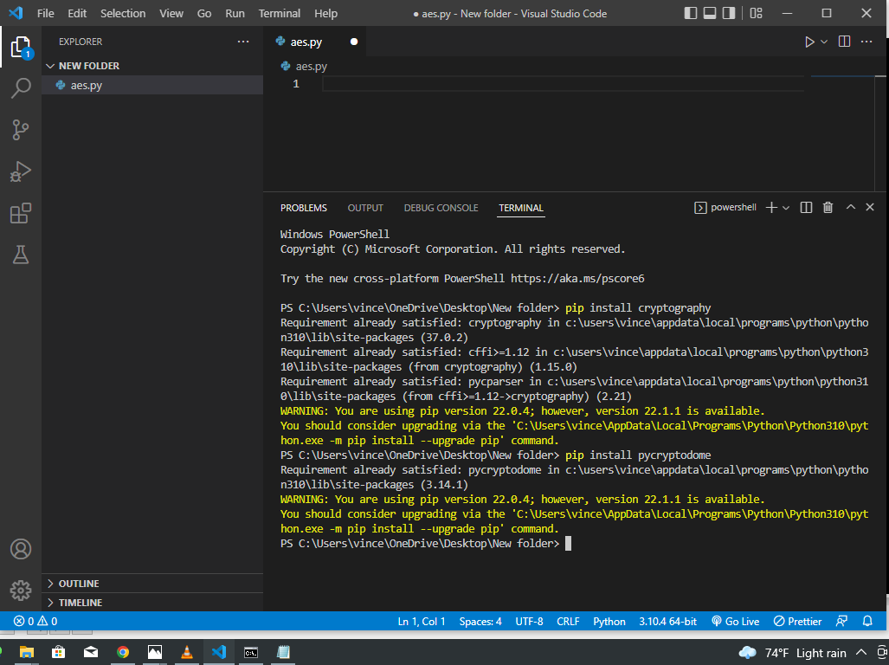

If the requirement is already satisfied. then skip to the next step.

Import AES. And token bytes

And define the encryption function that returns the cyphertext, nonce, and the tag.

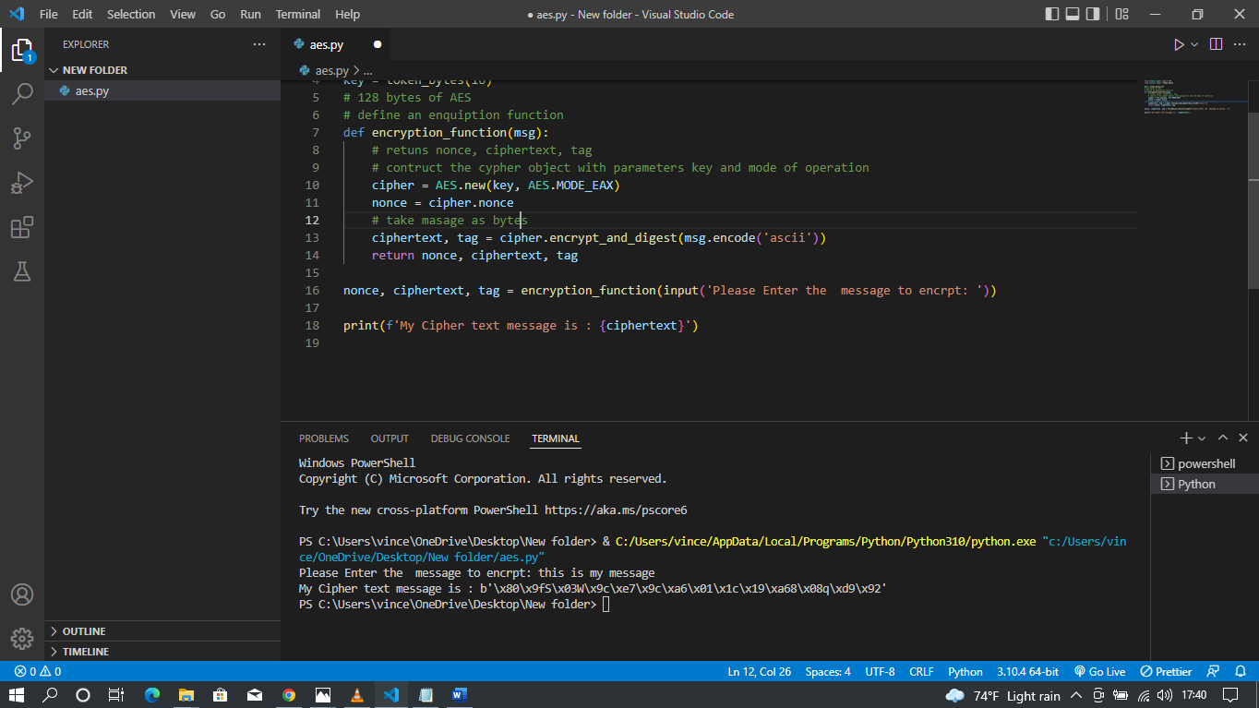

Define the description function with try and exception handling basically for verification if the plain text was properly encrypted as it tries to decode the bytes of ciphertext data.

